Happy Monday! I hope you all were able to have a nice weekend and were able to get outside during the breaks in the rain. As this continues to be a trying time please let me know if there is anything I can do to help with this transition!

Again, I have listed some ideas and resources you and your child can use to navigate the time away from school. I will also post everything to my website by week under the newsletter tab. My hope would be that your child spends time each and every day reading (at least 30 minutes) and practicing math skills (fact practice and or multiplications games). I will also include activities that can be done each week for social studies, science, and positive social emotional skills. Spending 15-20 minutes on Typing without Tears is an awesome way to build typing skills.

Week of March 30th

**Today’s Challenge: Can you create your own secret code? Think back to Book Scavenger! You could use letters, numbers, pictures or something else! Can you get someone in your house to break your code?** - Remember send me a picture and l I will post it to SeeSaw!

Reading:
For those of you who registered to use Epic! It will ask for a password. The password is qst3090.
While reading, stop & jot to hold onto your thoughts with a quick symbol.
Jot a symbol on a sticky note or scratch paper that shows your thinking about that part and place it on the page to mark your spot.
Each day choose 1 of your jots and share with a family member. Remember to tell them what is happening in that part, why you chose that part and your thinking about it.
- For example: My favorite part was (describe) because (describe).
- Or: In this part, (describe), I thought it was surprising because (describe).

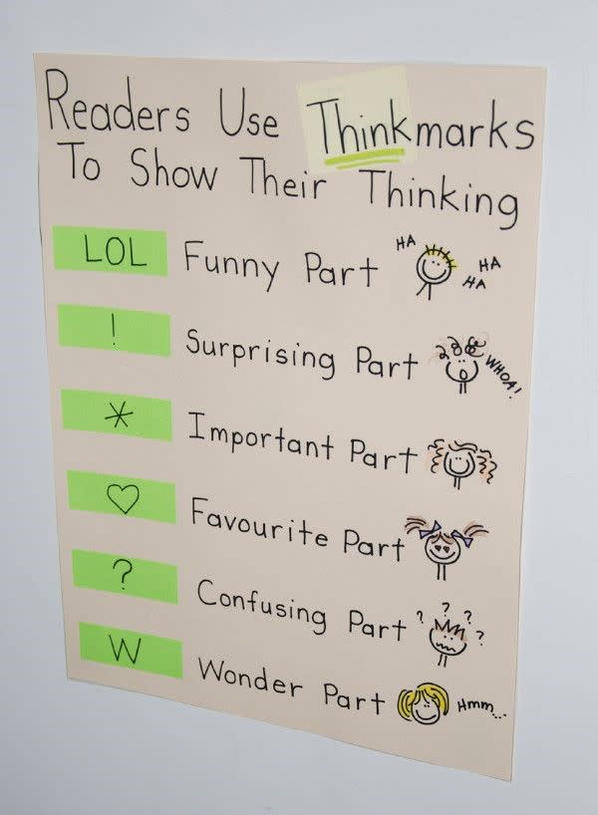
-Word Work: Word ladders are a fun way to manipulate words! Try this word ladder. Write your answers to the clues on a piece of paper and show your family!
Writing: Write a real small moment narrative story! Remember that we think of a small moment as a short moment in time, not a whole week or a day but a few minutes of a day. Try to narrow as much as possible something that really happened to you! Have fun with it and read to a family member when you are done.

Math:
- Keep working on Zearn. Aim for 3-4 lessons each week.
- Spend some time on Xtramath- Practice, practice, practice
Science:

Animal Adaptations, Part 1: Watch the video Adaptations to find out how special features of animal’s and plants’ bodies help them survive in their environments.
Draw a diagram of an animal you are familiar with (salmon, cat, dog, spider, etc.) and an adaptation that helps it survive.

Animal Adaptations, Part 2: Explain why investigating flies helped Tim Caro learn the reason zebras have stripes. What did Tim learn about that adaptation?

https://sciencespin36.scholastic.com/issues/2019-20/090119/why-do-zebras-have-stripes.html

Social Studies:

Why do People Live Where They Do?
This week think about why people live where they do.
Activity 1:
- Begin by drawing and labeling a map of your neighborhood. Include color and a key to identify important features of your neighborhood. For an example, or extension ideas, click here.
- Other items you may want to add are: compass rose, distance, natural resources such as parks, forests, or mountains nearby. For a challenge: find the elevation of where you live, average rainfall, and average temperature. Or, find your location on Google Earth (on Clever) and explore your neighborhood using this tool.
Activity 2:
- Think about what features you wish your neighborhood had. What would make your neighborhood more inviting, interesting, and/or special? Add those features to your map.
Addition resources:
- Gonoodle.com is a great resource for kids to get some of the wiggles out at home. It has indoor recess, dance videos, and short brain breaks.
- Storylineonline.com is a site that has books read aloud by actors. It is sponsored by the Screen Actors Guild. We have used this in class and the kids enjoy the stories. You can take a few minutes to ask questions about the characters, setting, etc. (reference the comprehension bookmarked handed out earlier this year)
- Dreambox is a fantastic math based site that is offering a free subscription. It is adaptive and offers kids a chance to move quickly through skills or to practice them more if needed.

*Send me pictures of anything they complete that they want to share. I would love to see what they are working on throughout the week!!*

