Happy third week of learning online. This will be the last week of review material. Things will change and ramp up after Spring Break. We will be using SeeSaw as our platform so I will try to assign a couple of the daily challenges on SeeSaw so we can all practice using the program! Remember if there is anything I can do to help your family please let me know. I hope you all are finding a little bit of joy in all of this! I sure do miss my students and my “routine” but I’m really soaking up all this extra time I’m getting with my family.
This email is SUPER long and is just loaded with activities that your student can work on throughout the week!
Aim to read a book of your choice 30-40 minutes each day.
**Monday’s Challenge: Hold a photo session! Take some amazing pictures! What will you photograph? Your pets, family, toys, something cool outside? You decide! Send me your favorite shots!**

Math: Continue to work through Zearn lessons- feel free to go back to other modules and complete lessons that have not been completed
Number Talk – Same and Different (unplugged)
Look at the pictures below.
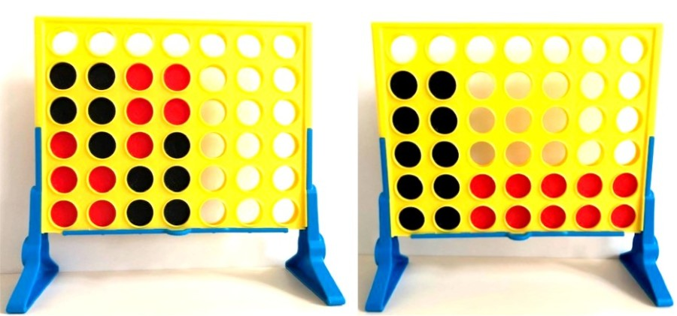

Can you explain 3 ways they are the same and 3 ways they are different?
You might say: Both pictures have ( ), and they also have ( ).
You might also say: The image on the left has ( ), but the one on the right has ( ).
Vocabulary: groups, row, columns, factors, product, multiple, array.
Family Math: It’s No Joke. Just 5 quick minutes of number fun for families.
Read a cool fun fact, followed by math riddles at different levels so everyone can jump in.

Reading: For those of you who registered to use Epic! It will ask for a password. The password is qst3090.
Reading Comprehension Practice (unplugged)
Strong readers consider all the influences on the characters that cause them to act differently.
Do you act differently when you are around your grandparents or your friends? Or when you are in a quiet restaurant versus a bouncy house? Just like you, other characters, settings and problems can have an influence on the characters in your books.
The problems the character is facing, the other characters with whom they come in contact and the setting of the story are all things that can change how a character acts and feels.
Choose a book you are currently reading or listen to the book Enemy Pie from Storyline Online. As you read, study how a character acts in different situations. When you notice a character acting a different way, jot it down (on a sticky note or scratch piece of paper) and then think about what influence the other character, setting or problem had on the character to make them act differently. You can track the influences and responses in one chapter or across an entire book.
This will help you understand the character from different perspectives and helps you see them as complete people.

Writing: Aim for writing about 30 minutes each day.
You might consider making a book about your real life right now.
Listen to this mentor text read by the author Patricia Polacco. Almost all of Patricia Polacco’s books are based on her real life.
Your real-life book might be called, “The time that all the schools closed for a while.”
Your book could contain narratives... stories of things you have done, experiences you have had, feeling you have felt.
It could contain information pieces about things you have learned such as washing your hands, cooking, using a new technology.
It could contain opinion pieces such as what has been good about being home as well as what has not been as fun.
This book might be one you’ll save and want to share with people in the future. In social studies, we learn books like this are called “primary sources.”

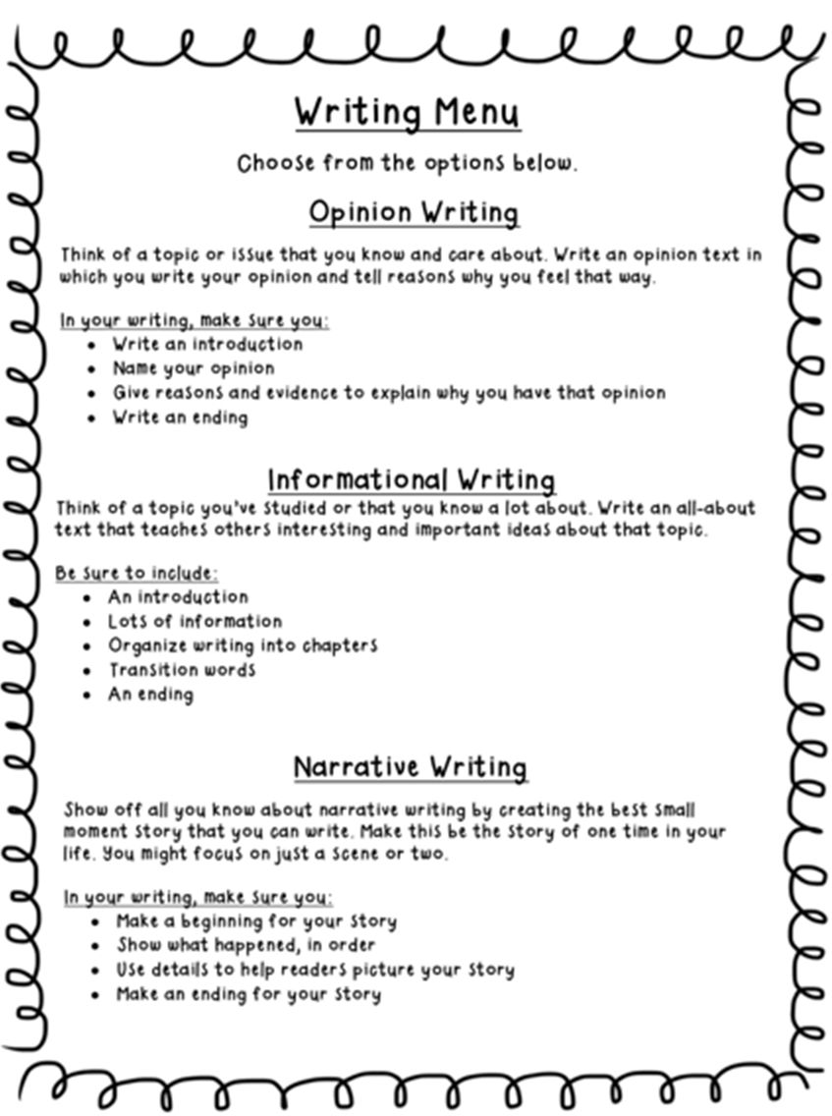
Science:
Engineering Based on Adaptations, Part 1
- Read A Better Brush to find out how an engineer got ideas for a new invention from her cat.
- Draw a diagram of the cat’s tongue. Explain the adaptation and how it helped the cat. What problem did it help the engineer solve?
Engineering Based on Adaptations, Part 2
- Watch the Inventions from Nature video to learn about other inventions inspired by animals, or even by plants.
- Observe an animal—maybe your pet, an insect, or a bird. If you can’t find an animal, observe a plant. What adaptations help the animal or plant get its needs met? How can those adaptations help you solve a problem?
- Draw diagrams for three or more different inventions that use ideas from the animal or plant.

Engineering Based on Adaptations, Part 3 (unplugged)
- Choose your best idea for an invention, give it a name, and then build your invention using materials you have at home, if possible.
- Test it out and then make changes to improve it.
- If you can’t build it, then create something (a poster, video, letter, etc.) to persuade others that they need to build your invention.

Why do People Live Where They Do? Part 2 This week we continue our thinking about why people live where they do.
Activity 1: Did you know the 2020 Census is underway? To learn more about the Census, read the parent letter. If your family has not already done so, complete the Census 2020 survey together online.
Activity 2: Study the Understanding the U.S. Population map.
Questions to discuss:
- What do you notice about where people live and where people don’t live?
- What information do the keys and graphs on the sides and bottom of the map tell you?
Activity 3: Explore how population has changed over time. Begin by looking at the State Population Change Over Time map. Some questions to think about and discuss are:
- What was Washington’s population in 1890? 1950? 2010?
- Did your state grow a lot (double or more) or just a little since 1890? What about the other state? Why do you think that is?
- Do you think the population of Washington will increase or decrease in the 2020 Census? Why or why not?
Activity 4: Let’s take a look at the Diversity: Differences in Communities table. Find the following information for Washington.
- Find the percentage of people in Washington, South Dakota, Texas and New Jersey that are: American Indian and Alaska Native, Speak a language other than English at home, have a Bachelor’s degree or higher.
- How does diversity in Washington State compare to the diversity in another state listed in the table?
Activity 5 (unplugged): Call, email, or even Face time a family member not living in your house and see if they have completed the Census 2020 survey yet. Share what you have learned about the Census with them. Or, think about questions you still have about the U.S. population and Census 2020. How could you go about getting your questions answered?
Click here for more Census 2020 activities
Wonderopolis: Welcome to Wonderopolis®, a place where natural curiosity and imagination lead to exploration and discovery in learners of all ages. Each day, we pose an intriguing question—the Wonder of the Day®—and explore it in a variety of ways.
Enrichment: Celebrate National Poetry Month
Read The Giant Water Bug by Douglas Florian for inspiration on how to write a poem about the natural world.
Then, write and illustrate your own poem about nature - as a bonus, post to Seesaw to share with me!

